**Summary of Major Findings**

**Group:** Ariel Dunn, Portia Anyamba, Irina Fedorova,

Allison Dorion, Matthew Yurich

**Summary:** The objective of our research and data analysis is to compare trends in homelessness by CoCs in the state of Maryland.  We will evaluate the data to see if there is any relationship between homelessness and its division amongst racial groups and average median household income.

**Question 1: What have the trends been over time for total homelessness per county?**

* Overall Homelessness in Maryland, as shown on “Total Homeless in MD (2015-2019)”, has been on a steady decline between 2015 and 2019. In 2015, Maryland had 8,390 homeless people, but over the course of 5 years it has dropped to 6,561. The greatest decrease in homelessness occurred between 2015-2016
* The next graph, “Homeless Over 5 Years Per County”, analyses homeless trends by county over a five-year period. Baltimore County has the highest unemployment rate, which has been on a steady decline from 2796 in 2015 to 2294 homeless people in 2019. Also, Montgomery County, Charles, Calvert, St. Mary’s Counties and Prince George's County’ homeless numbers have been declining steadily from 1100, 981, 625 to 647, 306, 447 respectively. Other counties have had insignificant fluctuations over time, except for Baltimore County that shows a significant reduction in numbers in 2017, which “adjusted back” to the normal range the following year.

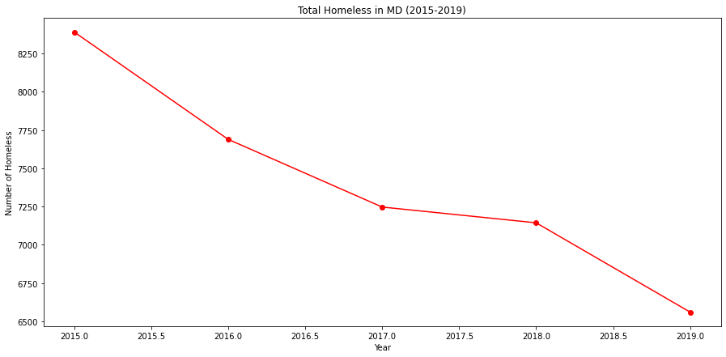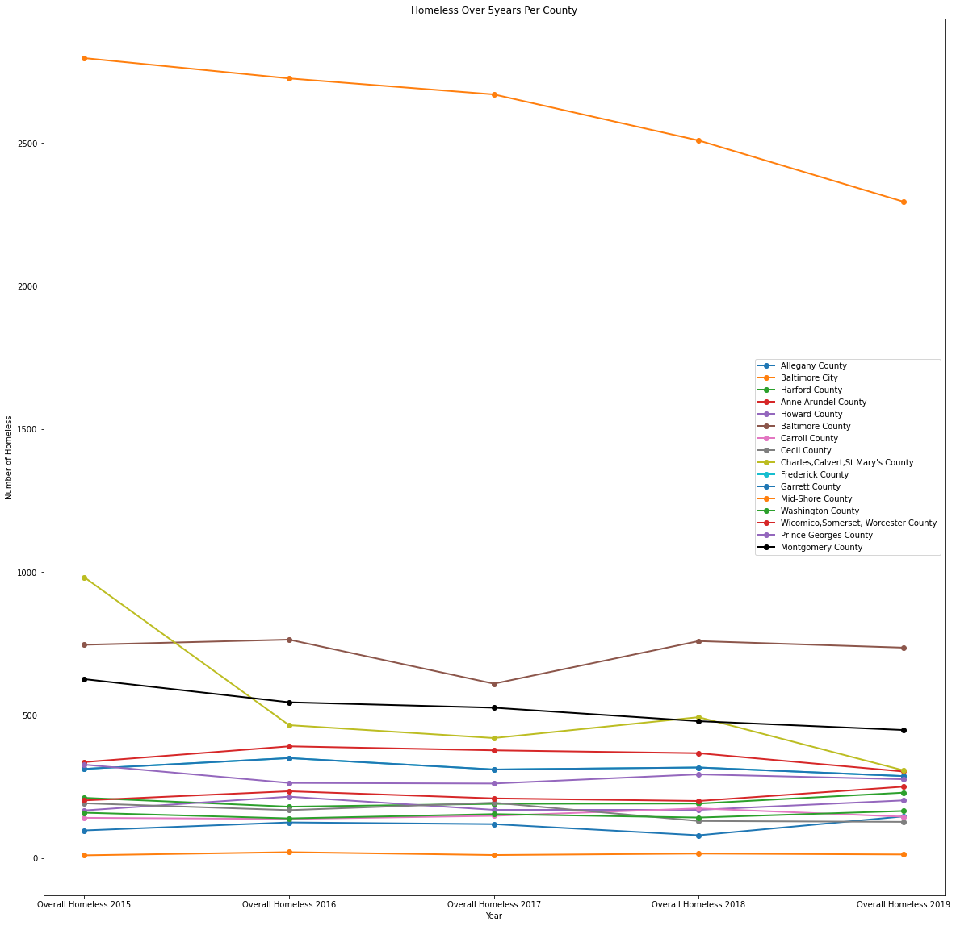

**Question 2: How is homelessness divided amongst racial groups in each county?**

* The bar chart “Homelessness by Race in MD counties in 2019” shows that the “Black and African American” group is making 57.6%, more than half of the homeless population in Maryland. The second category is “White” and it makes up 36.4% of the total homeless population. The third group is “Multi Races” - 4.3%. Other race groups are negligible by numbers. Each one less than 1%.
* The “Race of Homelessness by MD Counties in 2019” chart shows that Baltimore City has the highest number of homeless people 2294, a significant part is “Black or African American” – 1609, “White” – 602. The second highest county is Baltimore County. It has almost three times less homeless population – 735. Proportionally is almost the same 2:1 (“Black”: “White”). The other race groups are negligible by numbers. Prince George’s County has the Black or African American group as the majority of the homeless population at 91%.

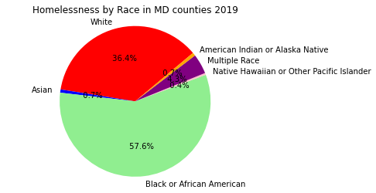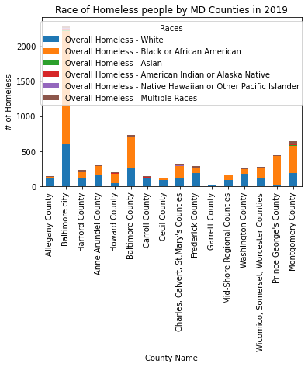

**Question 3: How does median income and the number of unemployed people relate to homelessness in each CoC/county?**

* The CoCs with higher average median incomes generally have a lower number of unemployed people**.** The counties with higher average median incomes and lower number of unemployed people generally have lower homeless populations. The top four counties for homelessness in Maryland, are also the top 4 counties in number of unemployed people (Baltimore City, Baltimore County, Montgomery County, and Prince George’s County), but there was not a significant relationship was found between the strength of a CoCs economy and their homeless population for the year of 2019.

